Fall 24 UX Design

Peer Feedback Desk Research

Peer Feedback
- Process where individuals provide comments and suggestions on each other’s works
  - Reviewers evaluate a manuscript to determine its quality and provide feedback to the author
  - Helps to identify errors and gaps in their work to improve

Research
Brill, J. M. (2016). Investigating peer review as a systemic pedagogy for developing the design knowledge, skills, and dispositions of novice instructional design students. Educational Technology Research and Development, 64(4), 681-705. https://doi.org/10.1007/s11423-015-9421-6&#8203;:contentReference[oaicite:0]{index=0}.

- This research explored peer review as a pedagogical tool for developing instructional design knowledge and skills in novice design students
- Data was collected through surveys, student work, and instructor observations.
  - Key findings: peer review improves the quality of design products and fosters a collaborative learning environment, though it has less impact on creativity.
- The study emphasised the need to cultivate a mindset that embraces the complexity of design, avoiding the notion of a single correct solution.

Main points
- Peer review positively affected students' knowledge, skills, and design quality
- Students found peer review valuable, though time-consuming
- It reinforced collaboration and problem-solving but was less effective for creativity
- A focus on embracing diverse solutions in design is needed

Despite some students initially resisting peer review or providing weak feedback, 99% found it beneficial, and 100% recommended its continued use.
- This positive response highlights peer review's role in fostering expert-like approaches in instructional design.

Research

"Peer Feedback in Peer Review: A Study of a Peer Review Activity in a Graduate Course" by Ghazali et al.

This paper reflects on a practical experiment conducted with a group of undergraduate students to show how peer feedback (on written work) is approached and practiced by students in English language courses.
Findings:
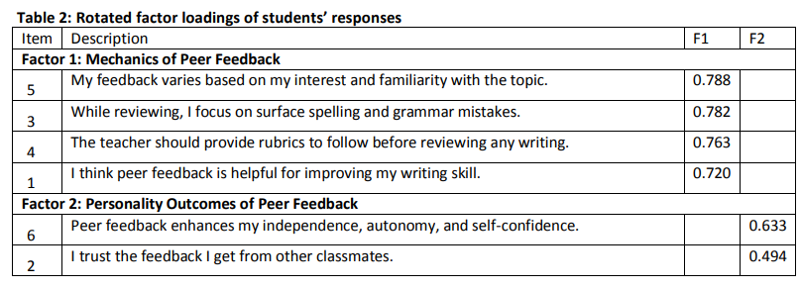

Article

"A Simple Tool for Peer Feedback in the Art Room" offers a practical approach to engaging students in feedback processes. It emphasizes the importance of using rubrics and structured feedback tools to guide students in assessing their peers' work effectively, making the process less intimidating.

This article speaks about a strategy called "Glow and Grow" that encourages students to seek peer feedback during the creative process by having respectful, structured discussions about their work. In this method, students can approach a peer to receive advice, focusing on both positive aspects ("Glow") and areas for improvement ("Grow"). The conversations follow a specific set of steps, guiding the students through a thoughtful critique. This method fosters collaboration and critical thinking, as students are encouraged to listen to the feedback but ultimately make their own decisions regarding the advice. It is used in classrooms for younger students (3rd to 5th grade) to promote responsible engagement with their artwork.

Strategy
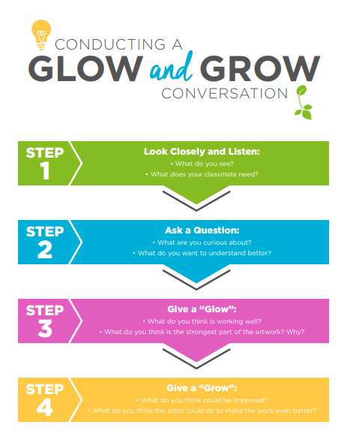 | 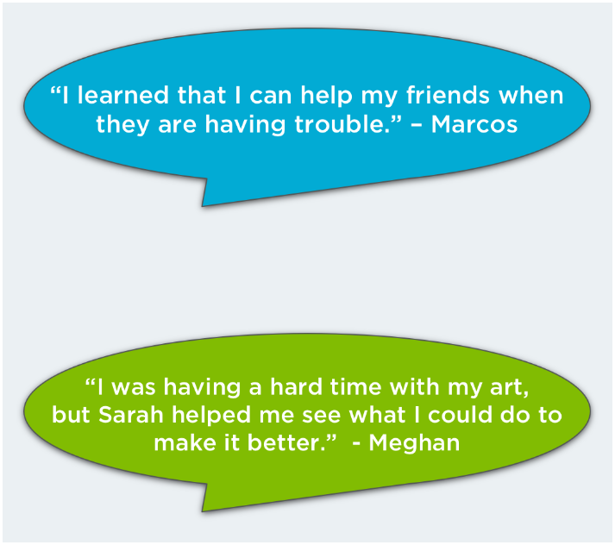

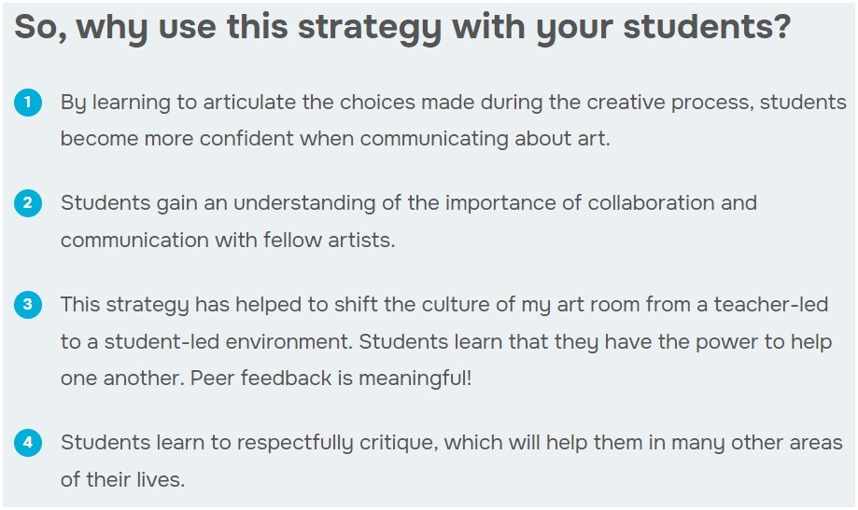

Rubrics

A rubric is a type of scoring guide that assesses and articulates specific components and expectations for an assignment. Rubrics can be used for a variety of assignments: research papers, group projects, portfolios, and presentations.

Rubrics help students:
Understand expectations and components of an assignment.
Become more aware of their learning process and progress.
Improve work through timely and detailed feedback.

The AACU has rubrics for topics such as written and oral communication, critical thinking, and creative thinking. RubiStar helps you to develop your rubric based on templates.

Art/Design Feedback Rubrics Samples

The Otis College of Art and Design’s rubric page offers practical examples of assessment rubrics tailored to creative fields such as design, drawing, and visual communication. These rubrics are designed to provide clear criteria for evaluating student work, ensuring constructive and consistent feedback. This resource is especially relevant for your project, as it highlights how structured feedback mechanisms can enhance learning outcomes for art and design students.

For example, Media and Design Elements Rubrics includes guidelines to assess based on Typography, Images, Audio & Video, Layout, Hyperlinks, Thoroughness, Evidence of learning outcomes, and more.

Peer Feedback Rubrics Sample

https://ldlprogram.web.illinois.edu/ldl-courses/syllabus/peer-review-rubrics/ : This rubric is intended for learning environments to provide structured feedback on academic writing and assignments. While not specifically designed for art and design, it offers a framework that could be adapted for creative fields.

Existing platforms

Miro
- Online collaborative whiteboard platform that can be used by design students
- Brainstorming, sharing ideas and receiving feedback in real-time

Figma
- Collaborative features allow multiple users to comment directly on a design file
- Students receive feedback in real-time
Google Docs
- Used to submit design work, and peers can provide feedback through comments or discussions within the doc or assignment space
  - Suggest: appears underlined, showing what was added
  - Editing: any changes (adding, deleting) immediately reflected in the docs
  - Commenting: highlight a section to comment, and once “resolved” it is removed from the view

Several digital tools are popular for facilitating peer feedback in educational settings:
- Canvas: Offers tools like FeedbackFruits for peer review and group member evaluation, allowing for structured peer assessment activities.
- Turnitin PeerMark: A tool for peer review assignments, enabling students to read, review, and evaluate papers submitted by classmates.
- Google Workspace Tools: Includes Google Docs, Slides, and Sheets, which allow for comments, task assignments, and text annotations, facilitating collaboration and peer review.
- PlayPosit (for video-based peer review): An interactive video creator that allows students to provide feedback on peer-submitted videos, useful for performance-based assignments.
- Zoom Breakout Rooms: Used for synchronous peer review sessions, allowing for real-time feedback and discussion.
- FeedbackFruits: Provides tools for peer review and feedback where students can follow a step-by-step process that involves submitting their work onto a platform, having it reviewed by their peers, and reviewing their peers’ work with an integrated rubric.
- Padlet: An interactive tool that allows for visual feedback, enabling users to post comments, images, and videos on a collaborative board.
- Bongo: A video assessment and feedback platform that allows students or team members to give and receive feedback on video-based assignments. The tool enables users to upload or record videos, and then peers provide critiques based on a rubric provided by the instructor or facilitator. This tool is particularly useful in settings like language learning, presentations, and art critiques, where verbal communication or visual demonstrations play a central role in evaluation.

